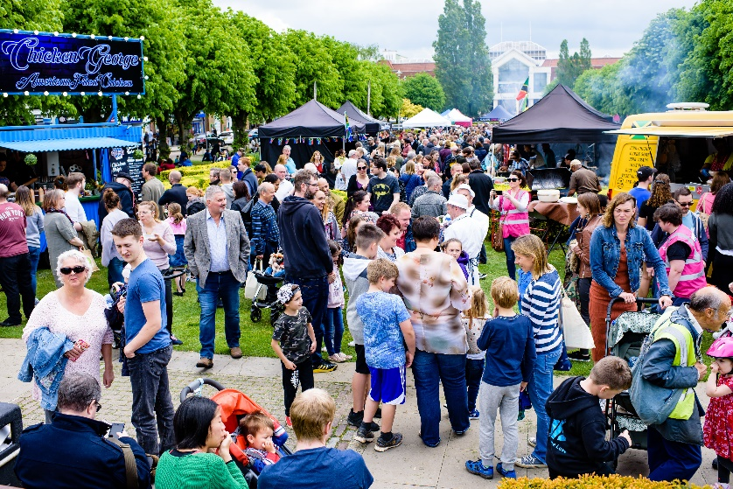
The World Food Festival
Wonderful Welwyn Garden City was transformed into a foodies’ paradise on Saturday 18 May by the World Food Festival, with 13,143 visitors coming to the town during 11am - 5pm.
At one point during the event there was an amazing 5,958 people enjoying the Food Festival on Howardsgate. One survey respondent said:
“A wonderful day out for all the family with decent prices, amazing food and great atmosphere”
Did you visit? We would love your feedback - complete the 2-minute survey and be in with a chance to win £25 shopping voucher! www.surveymonkey.co.uk/r/2X73ZSC
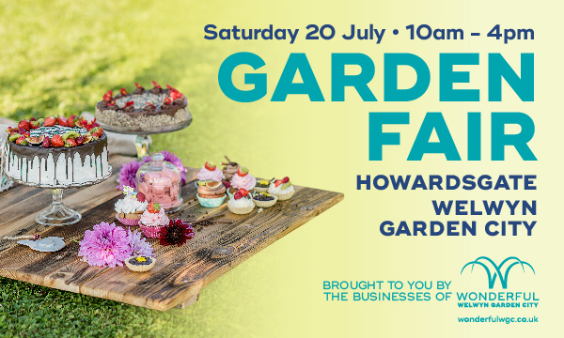
Garden Fair
This event is a quintessentially English affair of homemade delicacies, crafting, prosecco and acoustic music with a lovely chilled vibe.
There will be lots to keep the children entertained, including free face painting and photos with the children's favourite characters and instant prints to take home and treasure. We have mug decorating, sand art and much, much more...
For more information and help planning your experience visit www.wonderfulwgc.co.uk
Blooming marvellous!
Due to the many compliments we received from the public about last year’s town centre floral planters, the BID have commissioned more eye-catching floral displays for this year.
There will be 4 three-tiered planters and 14 barrier baskets as seen in the town last year, with 8 new design basket trees to bloom throughout the summer enhancing the environment of our town centre.
This year the BID flower installations will be entered into a BID Category in the Anglia in Bloom annual competition for the first time, wish us luck!
For more information and FAQs please www.wonderfulwgc.co.uk/bid-flowers
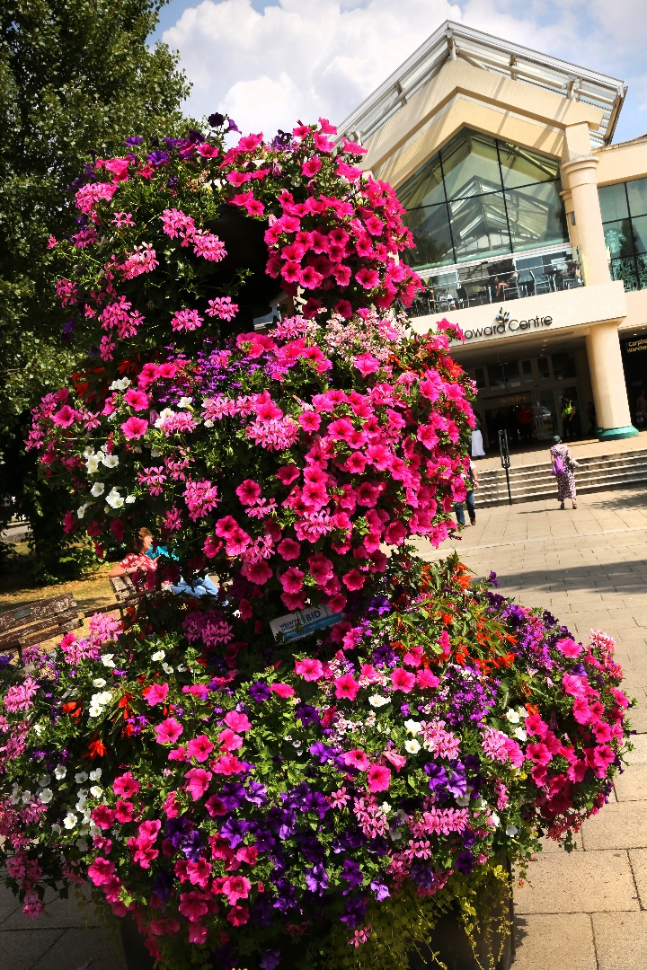

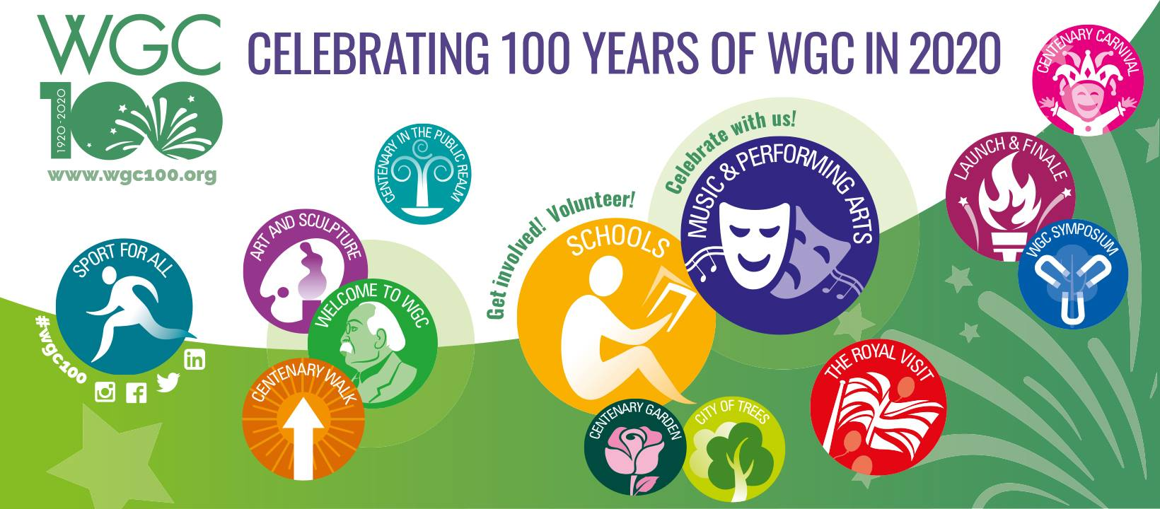
Would you like to know about the Centenary celebrations for 2020?
The Centenary Foundation is an organisation planning what is shaping up to be a fantastic year of celebrations for the hundredth birthday of Wonderful Welwyn Garden City.
For more information visit www.wgc100.org

WIN BIG
You can be in with a chance to win a bumper prize for the father figure in your life, by entering the competition on our website wonderfulwgc.co.uk

