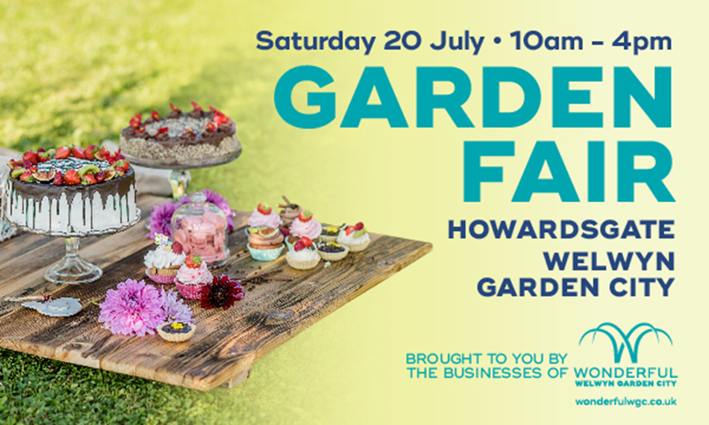

**Garden Fair**  
It's only 2 weeks until the Garden Fair which is a FREE event for all the family to enjoy on Satruday 20 July, 10 - 4pm.  
  
We are delighted to have **The Two Willows** and **Doctors Tonic** providing alcoholic refreshments, alongside **Bill's** Restaurant who are running the Tea Tent.  
  
Browse the market full of delicacies and craft products, many locally sourced. From fudge to jewellery, cards to hand massages by **Rituals**, there are plenty of delights to discover. Town centre business **Future Gifts** will be bringing all their beautiful blooms for sale if you want to brighten up your garden, along with some garden tools and ornaments.  
   
There will be lots to keep the children entertained. **Anytime Fitness** will be bringing all their energy to the party and **John Lewis** will be getting crafty with the youngsters and decorating mugs alongside mascots, face painting and games.  
  
**Waterstones** will be reading for children from the book 'I am the Seed that Grew the Tree', as well as crafting sessions 'Make your own flower book clip' throughout the day instore.   
  
There really is something for all the family to enjoy!  
   
For more information [**click here>>**](https://www.wonderfulwgc.co.uk/garden-fair)

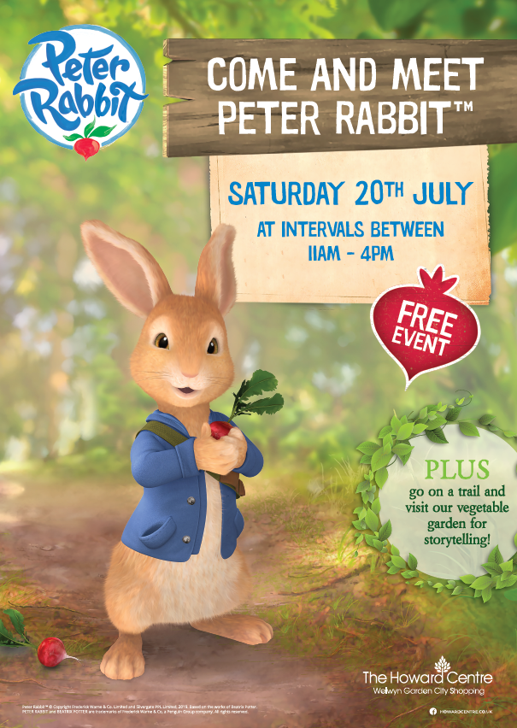

|  |  |  |  |
| --- | --- | --- | --- |
| |  |  |  | | --- | --- | --- | | |  | | --- | |  | | **Come and meet Peter Rabbit** Everyone’s favourite rabbit will be hopping into The Howard Centre on 20th July from 11am, come along for some woodland-themed fun! Plus, go on a trail and visit the vegetable garden for storytelling.  Peter Rabbit will appear at regular intervals: 11:00-11:40 12:00-12:40 1:30-2:10 2:30-3:10 3:30-4:00  For more information [**click here>>**](https://www.howardcentre.co.uk/events/everyones-favourite-rabbit-will-be-hopping-into-the-howard-centre-on-20th-july-from-11am/) | | |

**Our flowers flourish**  
The BID flower installations have arrived, and they look wonderful!  
  
We've received a huge number of compliments from the public already, who say they look fantastic and are delighted they have returned this year.   
  
The judges of Anglia in Bloom will be in town on the morning of Wednesday 10 July to take a look at all our efforts.  
  
For more information and FAQs please [click here >>](https://www.wonderfulwgc.co.uk/bid-flowers)and visit BID Flowers

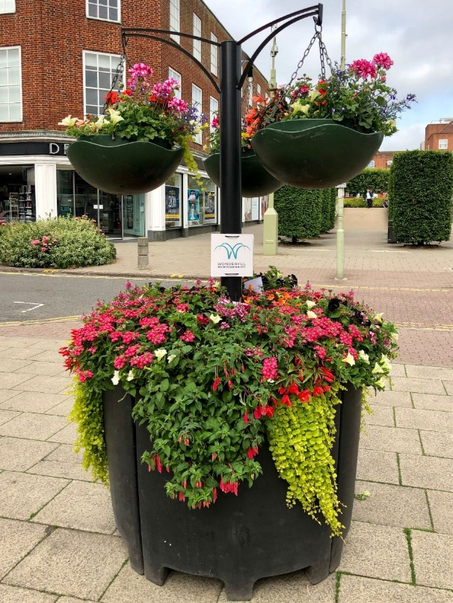



**Summer in the Garden City**

The WGC BID has produced this handy guide showcasing all that is happening over the summer in Wonderful Welwyn Garden City.  
  
Most importantly, it has all the details for the FREE Cinema on the Green event  returning this August!  
  
10,000 copies will be distributed in town and across Hertfordshire in the coming weeks, or you can view a copy online [**here>>**](https://docs.wixstatic.com/ugd/68ae1c_2aecbb3ada044e58b4304afc34d47bee.pdf)

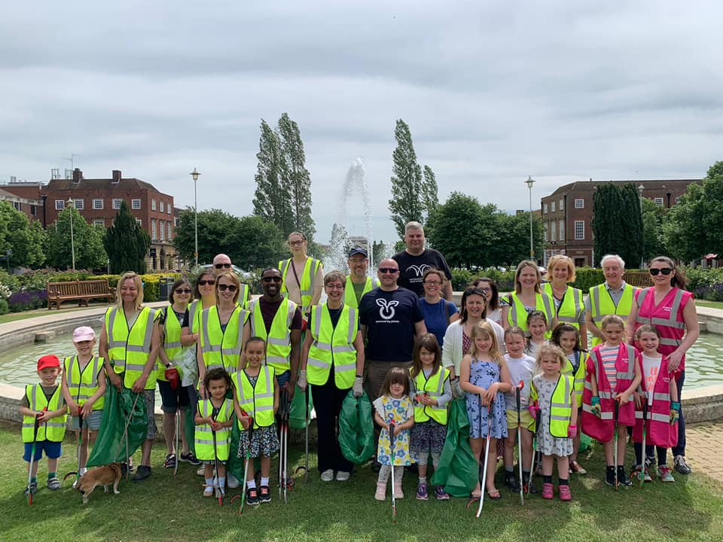

**The BIG WGC Clean Up**  
  
On Sunday 2nd June over 30 people of all ages came together to participate in the BIG WGC Clean Up in order to keep our town centre clean and green.  
   
Within the 90 minutes local businesses, councillors, employees and residents managed to clean up over 20 bags of litter from around the town centre.  
   
Due to the success and turn out we will be looking to do another WGC Clean up in August. For more information email  [ambassadors@wgcbid.co.uk](mailto:ambassadors@wgcbid.co.uk?subject=WGC%20BIG%20Clean%20Up)and follow us on Facebook [@wonderfulwgc](https://www.facebook.com/wonderfulwgc/)

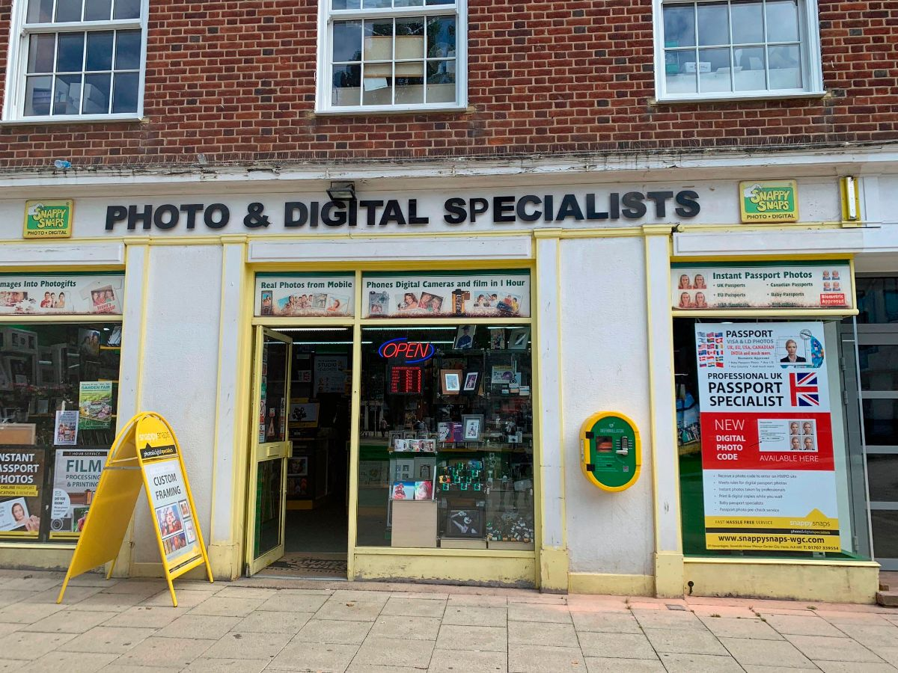

**WCG gets a new defibrillator**

Thanks to [**Dipps - Defibrillators in Public Places**](https://www.dipps4james.co.uk/dipps-defibs), **Welwyn Hatfield Borough Council** and our ambassadors we now have a 24/7 accessible defibrillator in Wonderful Welwyn Garden City located outside [**Snappy Snaps**](https://www.snappysnaps-wgc.com) in front of The Howard Centre.

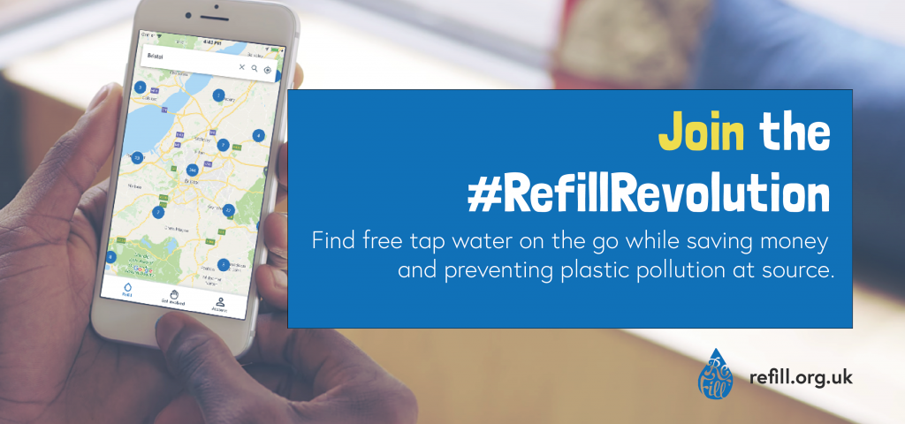

|  |  |  |  |  |
| --- | --- | --- | --- | --- |
| |  | | --- | |  | | |  |  | | --- | --- | | |  | | --- | | **Welwyn Garden City Joins the refill revolution.**  19th June 2019 was \***National Refill Day**\*   Welwyn Garden City have joined the refill revolution and have added 7 town centre taps to the map. **Waterstones** **Starbucks** **John Lewis and Partners** **Greggs** **Bill's** **The Two Willows** **Natural Health**   These businesses have all joined the revolution. The aim is to reduce the usage of single use plastic by allowing the public to refill their empty bottles at any of the above locations.   Download the App to find out your nearest refill station [www.refill.org.uk](http://www.refill.org.uk)**.**   **Will you join the revolution?** | | | |

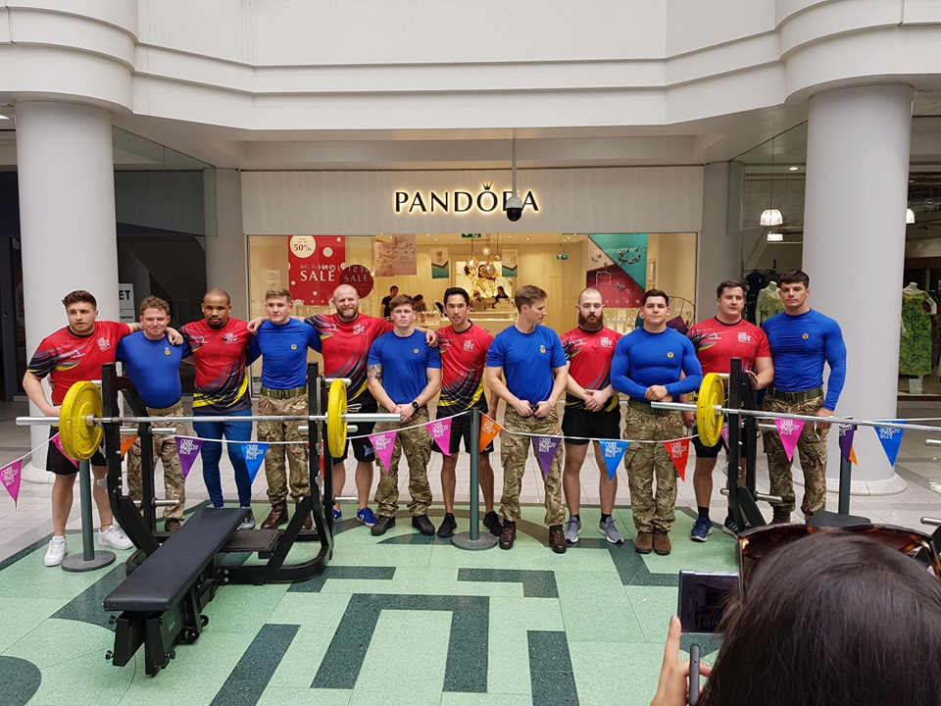

**Congratulations to Shaun Wall, The Howard Centre Manager for the amazing charity event One Great Day!**   
  
Saturday 22nd June, The Howard Centre’s One Great Day event saw 2 teams of 6 attempting to lift 13 Hercules aircraft in 6 hours, 447,200kg in total weight, each team member lifting the equivalent weight of 2 aeroplanes each.  
   
Both teams absolutely smashed the time of 6 hours with the RAF Regiment finishing in 3 hours 55 and The Howard Centre closely following with 4 hours. The event was a great success with an amazing atmosphere in the centre. They have currently raised £3000 for Great Ormond Street Hospital and Willow Foundation, should you wish to donate [**click here>>**](https://www.justgiving.com/fundraising/thehowardcentreogd)

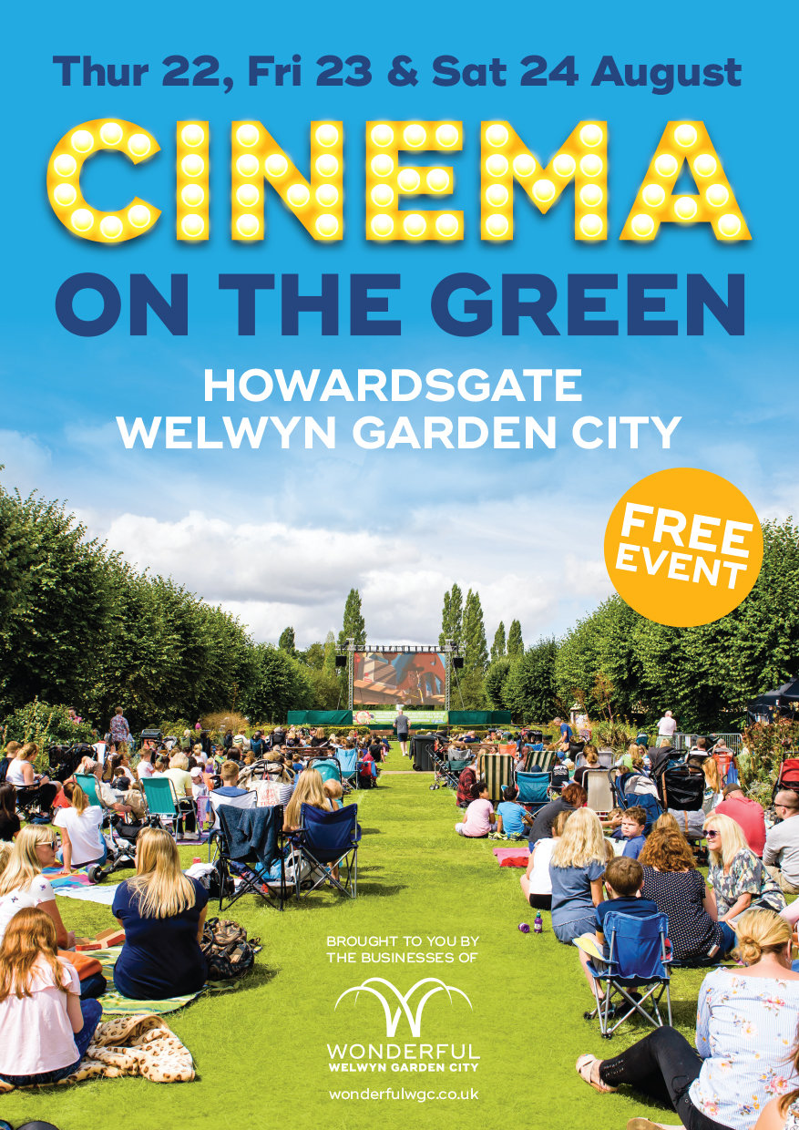



|  |  |
| --- | --- |
| |  | | --- | | **BIG Summer Presents** 1st August, 11am - 3pm, Welwyn Garden City town centre.   Reach new heights in Wonderful Welwyn Garden City, on our mobile rock climbing wall coming to the town centre along with other activities for all of the family.   **Skate Camp** 9th August, 12:00 - 2:00pm, Cherry Tree car park, WGC. Come along and learn how to ride a bike, scooter and skateboard with professionals. Recommended age 3 -13 years older   **Skate Jam** 9th August, 4:30 - 8:30pm, Cherry Tree car park, WGC.  There will also be competitions and prizes | |

|  |
| --- |
|  |

